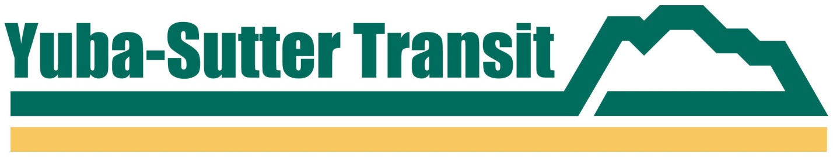

**PRESS RELEASE**

**YUBA-SUTTER TRANSIT**

**2100 B STREET, MARYSVILLE, CA 95901**

**Contact: Jessica Solis or Matthew Mauk**

**Phone: (530) 634-6880**

**FAX: (530) 634-6888**

**FOR IMMEDIATE RELEASE**

**BOK KAI FESTIVAL PARADE SERVICE DETOURS**

*February 21, 2025, Marysville, CA* – The 145th Bok Kai Festival, celebrating the Year of the Snake, will take place in downtown Marysville on Saturday and Sunday, March 1st and March 2nd. As a result, Yuba-Sutter Transit’s Route 1 and 4 will not serve bus stops on B Street, D Street and F Street on Saturday, March 1st.

The nearest alternative downtown stops in Marysville for Routes 1 and 4 on Saturday, March 1st, will be on 3rd Street at or near the Adventist Health and Rideout Hospital.

For more information, please visit our website at [www.yubasuttertransit.com](http://www.yubasuttertransit.com)

###