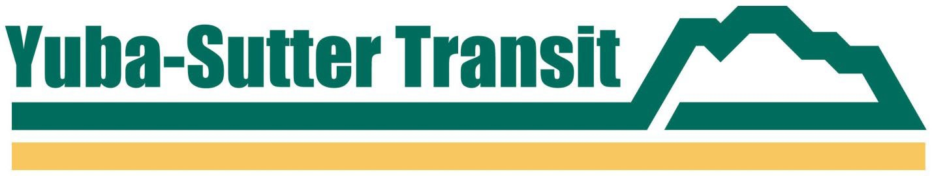

PRESS RELEASE

**YUBA-SUTTER TRANSIT**

**2100 B STREET, MARYSVILLE, CA 95901**

**Contact: Adam Hansen or Matthew Mauk Phone: (530) 634-6880**

**FAX: (530) 634-6888**

**FOR IMMEDIATE RELEASE**

**MARYSVILLE CHRISTMAS PARADE BUS STOP CLOSURES**

*November 27, 2024, Marysville, CA* – The Marysville Christmas Parade returns to downtown Marysville on Saturday, December 7, 2024. Due to the combined event street closures and detours from Highway 70, Yuba-Sutter Transit’s Route 1 and Route 4 will not serve D & 2nd Street, F & 2nd Street and all bus stops south of 9th Street and West of Highway 70 after 1:00 p.m. on Saturday, December 7th.

The nearest alternative downtown stops in Marysville for Routes 1 and 4 will be on 3rd Street at or near the Adventist Health and Rideout Hospital.

For more information, please visit our website at [www.yubasuttertransit.com](http://www.yubasuttertransit.com/). ###